SOC

Startup on the cloud

SRS

Introduced By Team 20

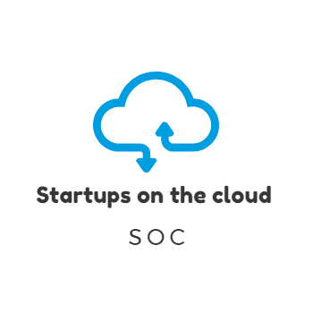

|  |  |  |  |  |
| --- | --- | --- | --- | --- |
| Version | Written By | Reviewed By | Approved By | Date |
| 0.X | Team 20 | Menna Mohamed | Dr.Sobh | 25/11/2018 |
| 1.X | Team 20 | Menna Mohamed | Dr.Sobh | 2/12/2018 |
| 2.X | **Team 20** | **Menna Mohamed** | **Dr.Sobh** |  |
| 3.X | Team20 | Rita ehab and reham Ashraf | Dr.Sobh | 14/2/2019 |

# Team Contribution

|  |  |
| --- | --- |
| Name | Role of each person |
| Rita Ehab &  Reham Ashraf | Domain requirements and system description |
| Menna Mohamad | Prototype and revision of SRS |
| Mona Mahmoud | System users |
| Menna Hussein | System interface |
| Salma Hesham | Non-functional requirements |
| Haidy Samir | System models |
| Nour Elhoda Ashraf | Functional requirements |
| Esraa Mohsen | System modules |
| Mennat-allah Ayman | The Introduction |

Contents

Team Contribution 2

1. Introduction 1

1.1. Executive Summary 1

1.2. Document Overview 1

1.3. Abbreviations and Terminologies 1

1.4. References 1

2. System Description 2

3.1. Introduction 2

Data flow diagram 2

3.2. Users 4

3.2.3. Developers 4

3.3. Modules 5

2.3.1. User Management Module 5

2.3.2. Owner Management Module 5

2.3.3. Feedback Module 5

3. System Users 6

3.1. Developers 6

3.2. Owners 6

3.3. Customers 6

4. System Modules 7

4.1 User Management Module 7

4.2 Owner Management Module. 9

4.3 Feedback Module. 11

5. System Functions 12

5.1. Create accounts 12

5.2. Startup page 12

5.3. Filter startups 12

5.4. Set promo codes 13

5.5. Give a feedback 13

5.11. Place of the day 14

5.12. Edit 15

5.13. Sorting 15

6. System Models 16

Use Case Diagrams 16

Sequence Diagrams 19

7. Non-Functional Requirements 23

7.1. Security 23

7.2. Usability 23

7.3. Performance 23

7.4. Development 23

8. Domain Requirements 24

8.1. Market Requirements 24

9. System Interfaces 24

9.1. User Interfaces 24

9.2. Hardware interfaces 32

# Introduction

## Executive Summary

”Startups on the cloud” is a website which can be considered as the linkage between startups and their customers. It will be a very important tool for startups owners in order to market their projects. Startups on the cloud will also help whoever is looking for new nearby place (ex.: restaurant, café or co-working space) to find it easily.

## Document Overview

This document contains a description of our project. It describes and illustrates the diagrams of the system. It also illustrates the functions of the system. These functions are: the functional requirements, the nonfunctional requirements, and the domain requirements as well. Not only that, this document provides the system user which provides user role description in details.

## Abbreviations and Terminologies

|  |  |
| --- | --- |
| SOC | Startups on cloud |
| UP | User profile |
| OP | Owner profile |
|  |  |

## References

1. https://en.wikipedia.org/wiki/Software_requirements_specification 2- The SRS template’s doctor.

# System Description

## Introduction

Startup on the cloud website is an online meeting point between customers and startup owners where startup owners can provide their startup service showing their category of service (Co-working space, event and project planning, handmade jewelry, custom clothes, open days, startup café, entertainment place, keto foods, vegan food). And from the customer side he/she can search for the category of place they want to visit and have an access to the location and ratings and reviews and after their visit they can give feedbacks and pros and cons about the startups so others can see, and also see the clouds rating

### Data flow diagram

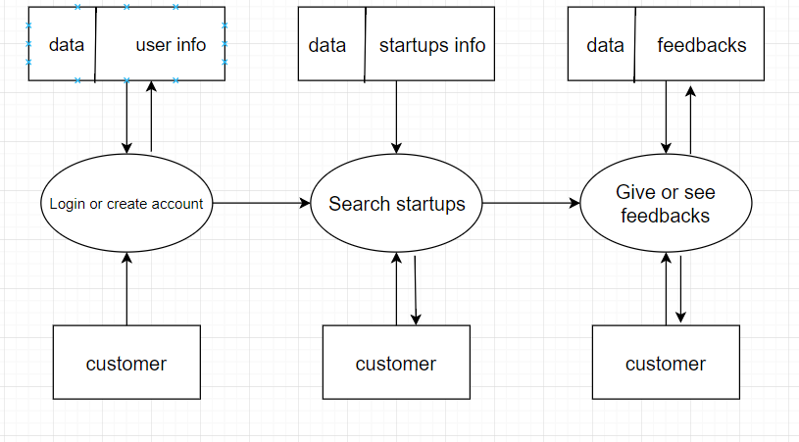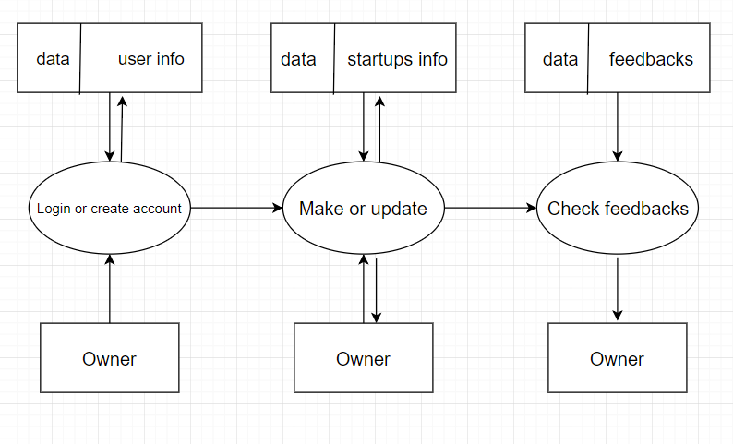

Context diagram

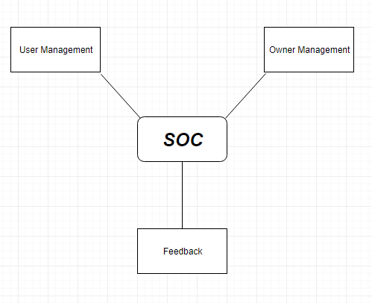

## Users

#### Owners

#### They’re the owners of the startups who have an OP.

#### Users

#### They’re our viewers of our website who have an UP.

## Developers

They are responsible for creating & designing the webpages, managing the system operations and contents.

## Modules

The system consists of following modules

* + 1. **User Management Module**  
        Sub modules:

1. User Access
2. Viewing Offers
3. Getting Promo codes
4. Startup’s Description
5. Rating & Recommendation

User Access sub module is responsible for all users’ data.

Promo codes are generated by startup owners.

Startup’s Description section shows couple of lines describing the startup written by the startup owner, to give Users some extra details.

Rating sub module is divided into general startup rating and CloudRating.

* + 1. **Owner Management Module**  
       Sub modules:  
       a- Owner Access  
       b- Giving Offers & Promo codes  
       c- Profile View & Update  
         
       Owner Access sub module is similar to that of user concerning the obligation of having an account.   
         
       Offers & Promo codes sub module is subjected to generating promo codes & offers by the owner of each startup.  
         
       Profile View & Update sub module is responsible for viewing startup contents and information. Owner can update images to his startup.

## Feedback Module This module is responsible for gaining users’ reviews after dealing with startups.

# System Users

## Developers

They are responsible for creating & designing the webpages, managing the system operations and contents. If the website user faces a problem & reports a place for example, we directly send him/her an email with a form containing some questions which are the place name, the issue, when did this problem happened , was it the first time, what could the place do to compensate you? , and any other comment, this helps us a lot, because if a certain place got a certain number of reports, we as the supervisors send him an email and warn him/her, and if they don’t take an action, we delete the project from the website after giving him/her enough time to do something.

## Owners

The owner of the startup can create his own page, he/she can control it by writing description, uploading pictures or videos of the place & he/she can also update them, he/she can put their location so it helps the user to reach the destination faster. One of the important features he/she has is replying to the customers and communicating with them. But his/her account has some different features than the user, he/she can’t search for any other page using this account, they have to make another account as a user, because the user is the one who can do that.

## Customers

Customer can create account, search for a nearby start-up (for example: co- working space, café or restaurant), add likes, comments and feedback. Customer can use the report button to announce for a problem so we send him an email containing a form to tell us his issue. The owner will be informed if the reports about a problem exceed a certain number, in order to reach the customer’s satisfaction and trust. There is also ‘contact’ us form if the user faces any problem with the website, if he wants to leave a message or a comment and it also have a rating question concerning the website.

# System Modules

* 1. **User Management Module**  
      Sub modules:

1. User Access
2. Viewing Offers
3. Getting Promo codes
4. Startup’s Description
5. Rating & Recommendation

User Access sub module is responsible for all users’ data. On visiting the website, User is asked whether they already have an account. If yes they go through sign in process giving credentials. If not it’s obligatory to sign up to get into website and its services.

Through Viewing Offers sub module User is able to access and view offers presented by startup Owners.

Promo codes are generated by startup owners, giving particular number of promo codes every day. Users click on “get promo code”. The generated promo code appears.

Startup’s Description section shows couple of lines describing the startup written by the startup owner, to give Users some extra details.

Rating sub module is divided into general startup rating and CloudRating. User chooses rating on 5 cloud icons representing 5-cloud-rating. General rating is based on users CloudRating versus number of reviews. If user enjoys a startup, he can recommend it using Recommend-star button.

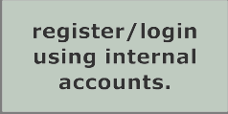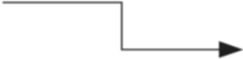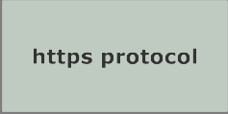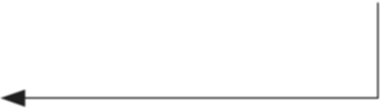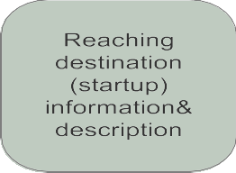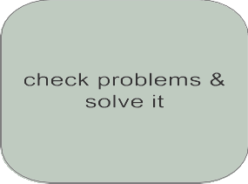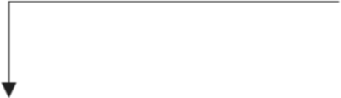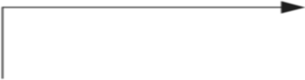

* 1. **Owner Management Module**  
     Sub modules:  
     a- Owner Access  
     b- Giving Offers & Promo codes  
     c- Profile View & Update  
       
     Owner Access sub module is similar to that of user concerning the obligation of having an account. On signing up, Owner should enter some information about startup like: name of startup, description, location, type of service, working hours, also username and password.  
       
     Offers & Promo codes sub module is subjected to generating promo codes & offers by the owner of each startup.  
       
     Profile View & Update sub module is responsible for viewing startup contents and information. Owner can update images to his startup.

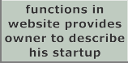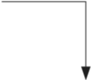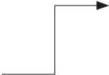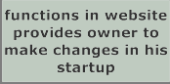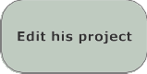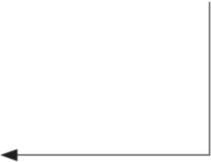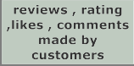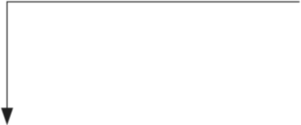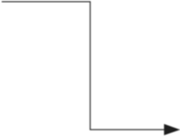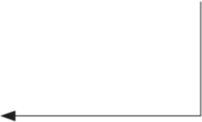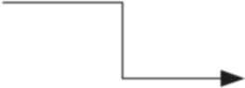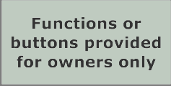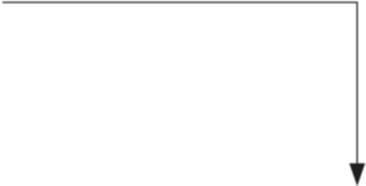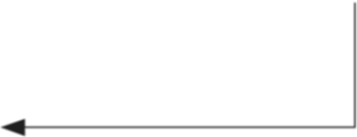

## Feedback Module This module is responsible for gaining users’ reviews after dealing with startups. User gives feedback about certain service criteria example: quality, prices, etc. Then User is allowed to give his own words of feedback. Previous feedbacks appear and new ones are generated.

# System Functions

## 5.1. Create accounts

-Description: SOC allows you to create account for both our customers and the startup owners. At the start page, user should decide whether to enroll as a customer or a startup owner. SOC offers two different forms for each kind of user.

-Inputs: Customers should provide their name, e-mail, and phone number. Startup owners should provide the startup’s name, kind of service, e-mail, location in details (Format: building number, street, district), Google maps link, national ID, working hours and images.

* Output: The page as a user or owner according to the input information.
* Pre-condition: entering a valid data.
* Post-condition: database is established with a record for the user.

## 5.2. Startup page

-Description: The Startup page contains information about the startup. Moreover, the owner can check the reviews of the customers.

-Input: owner’s email and password.

-Output: startup page is opened.

-pre-condition: entering a valid data

-Post-condition: database is established with a record for the owner.

## 

## 5.3. Filter startups

-Description: SOC offers categories for users to choose from, after the user choose his/her district, the results will be filtered

-Input: choosing the wanted category.

-Output: The results shown to the users will be filtered according to their choices and preferences.

-Pre-condition: User must be logged in to the website.

## 

## 5.4. Set promo codes

-Description: This allows the owner to set the number of promo codes per day, and how much for each user, and the user can get one once he visits our website and the promo code is available.

-Output: getting the discount.

-Pre-condition: logged in as a user.

-Post-condition: number of the promo codes the user used saved in the database

## 5.5. Give a feedback

-Description: SOC provides some questions as MCQ, at the end there is a textbox for the users to express their opinions about the places or the events they attend.

-input: the answer of the questions and comments in the textbox

-Output: showing the feedback as comment on the page

-pre-condition: logged in as a user

-post-condition: the feedback will be saved in the database.

**5.6. User profile**

-Description: It displays his/her visited places, general info as: name, e-mail, phone number and city.

-Input: E-mail and password as a user.

-Output: Home page will be viewed.

-Pre-condition: Entering valid data.

-Post-condition: Database is established with a record for the user.

5.7. **Display the highest recommended startup**

-Description: Highly recommended startups have the privilege to be at the top of search results which will increase the popularity of this startup.

-Pre-condition: User must be logged in.

-Output: The places will appear in order from the highest to the lowest recommendation.

5.8. **About**

This Page mentions the aim of SOC, year of establishment, the founders and other general information about the website.

-Input: clicking on the about button

-Output: page with about information of the website.

-Pre-condition: searching for the SOC website.

**5.9. Recommendation**

-Description: They can recommend startups. The number of recommends hits will be displayed on the page. Ones with highest recommendation numbers will be shown at the top of the search result. And because startup can be good, very good or excellent, recommend won’t be enough to describe the excellence of a startup rather than another one. SOC provides cloud rating.

-Input: hitting the button.

-Pre-condition: logged in as a user.

-Post-condition: saved in the database to calculate automatically the total recommendation for the place.

**5.10. Rating**

-Description: Because startup can be good, very good or excellent, recommend won’t be enough to describe the excellence of a startup rather than another one. SOC provides cloud rating. Which is 5 clouds the user rate the place by clicking on the clouds from 1 to 5

-Input: Clicking on the the clouds

-Output: total rate after

## 5.11. Place of the day

-Description: The website displays a place that is highly rated as the place of the day. This place changes daily and another place with high ratings gets the title and replaces the previous one.

-Input: just logging in to the website as a user.

-Output: place of the day will show up in all pages.

## 5.12. Edit

-Description: User can make changes in his name, e-mail, phone number, and password

-Input: The new data

-Pre-condition: logged in as a user.

-Post-condition: The new entered data will be saved in the database.

## 5.13. Sorting

-Description: The user can find his wanted place in two ways, first one by recommendation where the places will be ordered from the highest to the lowest recommendation, the second way by location where the places will be ordered from the closest to the farthest according to the user location.

-Input: the wanted place.

-Pre-condition: logged in as a user.

-Output: the wanted places in order.

# System Models

## Use Case Diagrams

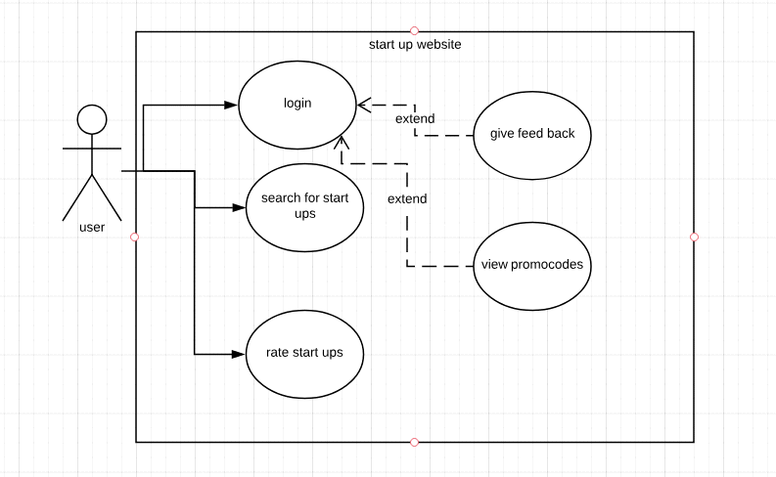

-This use case diagram shows the relation between the users of the website and the function he could do on the website, he could login to a personal account which gives him the authority to do many features such as feedbacking service and view promo codes to get discount from service owners for using our website.

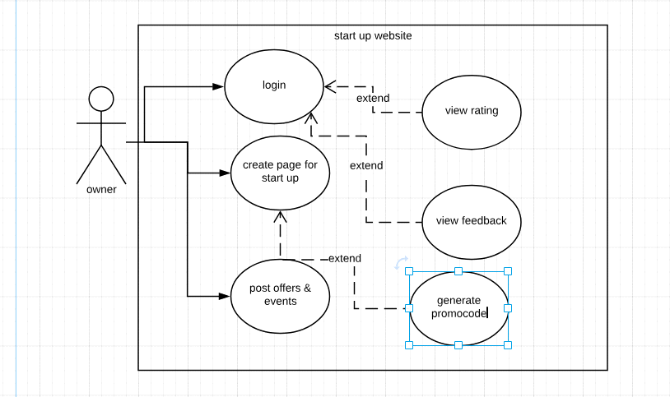

-This use case describe the relation between the owner of startups and the function they could do on it such as creating page for marketing their startups and view the ratings of customer and benefit from their feedbacks to avoid mistakes and give a better service, they could also post about events and offers for customer.

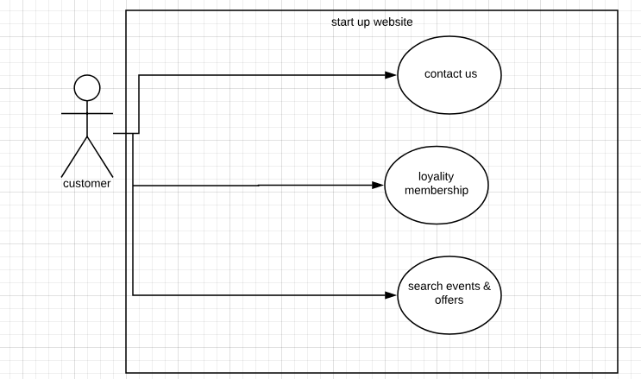

-This use case diagram shows the relation between the users of the website and the function he could do on the web site ,he could contact us for any problems and we will follow up with him ,he also has a loyalty membership which give him advantages for using web site, finally he could search events and offers occurring soon.

## Sequence Diagrams

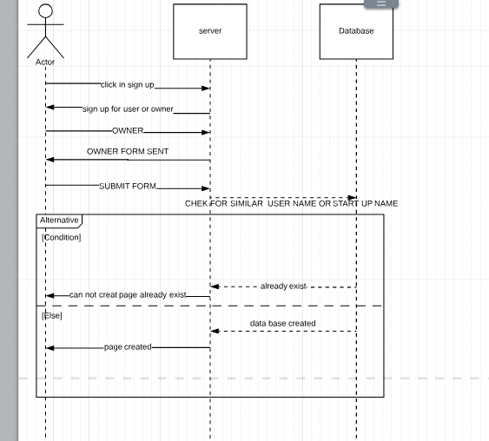

-This sequence diagram is used to show up a certain process function when owner asks to create a page on our website the server should check in the data base that the entered user name and start up name doesn't exist to avoid repeating and problems later and if it is ok the page will be created successfully if not error message will pop for invalid information

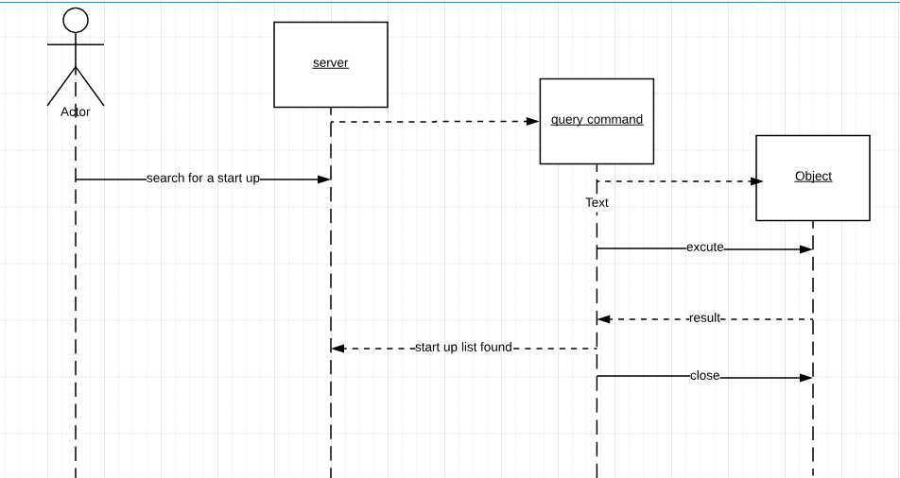

-This sequence diagram describe one of the basic functions on our website which is searching engine for startups as the user enter the service name a query connecting all the entered information is sent to the database which give back all nearby results to the user and sent back to him to choose the best for him

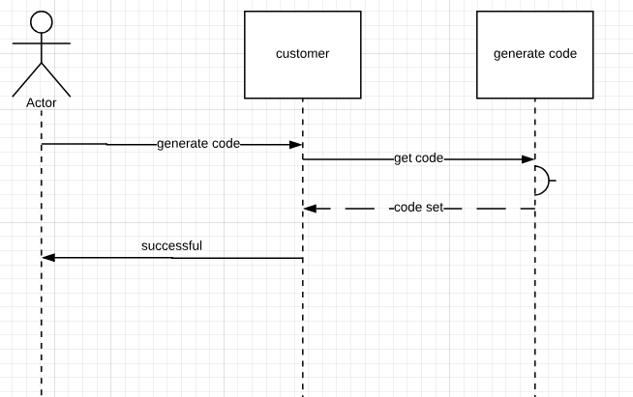

-This sequence diagram is used to show up a certain process function when customer asks to generate a promo code the class customer activate class generate code and ask it to generate a code and give it back

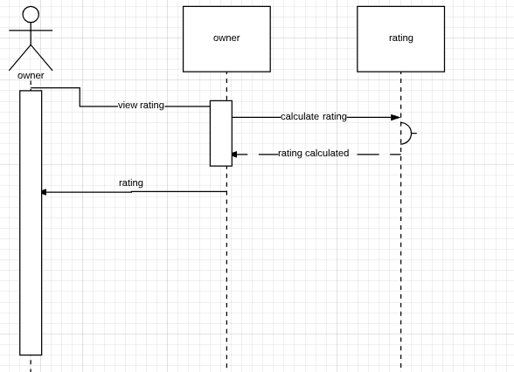

-This sequence diagram describe a process made by owners which is viewing their ratings up, the class owner give a calculate order for class rating which calculate the rating and give it back

# 

# Non-Functional Requirements

## Security

The website must be secure to insure the privacy of each user and to protect the user's accounts and information. This is achieved by using a proper login system as the user is requested to enter their own distinct usernames and passwords to avoid hacking.

## Usability

The website must be user friendly to facilitate user's interactions and usage of the website. The users will be able to use this website easily and effectively

## Performance

There will be a continuous interaction between the users and the website to ensure high quality performance and to make sure that each user enjoys an excellent experience and reaches the most relevant information to his request in a short time. The response of the system is fast.

## Development

The website is written using agile process.

# Domain Requirements

## Market Requirements

Feedback and reviews are required to let owners cope with customer desires.

# System Interfaces

## User Interfaces

* The users in our website are classified into:
* Owners of the startups
* Customers
  + - The Owner will be able to
    - See all the categories (co-working spaces, cafés, and restaurants), so he can choose any of them.
    - Sign up to the website.
    - Login to the website where he can get the available promo codes.
    - Get in contact to the website owners in ‘contact us’ page.
    - Add, edit or delete his project.
    - Add a detailed description of his project (images, location, menus, offers…etc).
    - See the reviews of his project.
    - Set the number of available promo codes per day.
    - Get notified by taken promo codes.
    - The Customer will be able to
* See all the categories (co-working spaces, cafés, and restaurants), so he can choose any of them.
* See the reviews of certain projects.
* Sign up to the website.
* Login to the website where he can get the available promo codes.
* See the description of each project.
* Get in contact to the website owners in ‘contact us’ page.
* Report certain projects if any issue happen.
* See the description of the website in ’About’ page
  + - Examples on Interfaces
* Sign up form

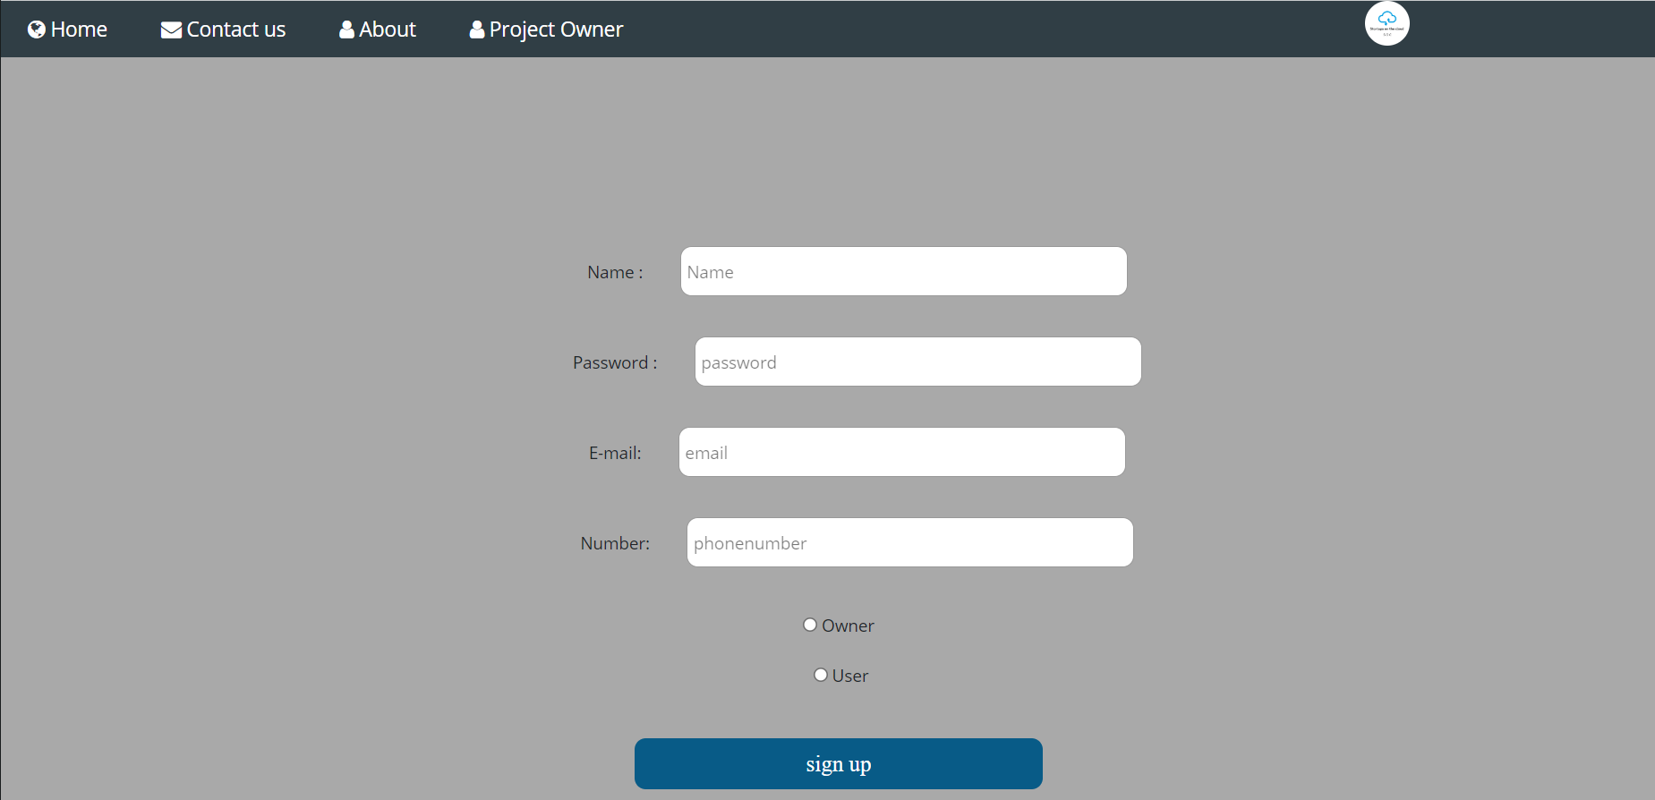

* Login form

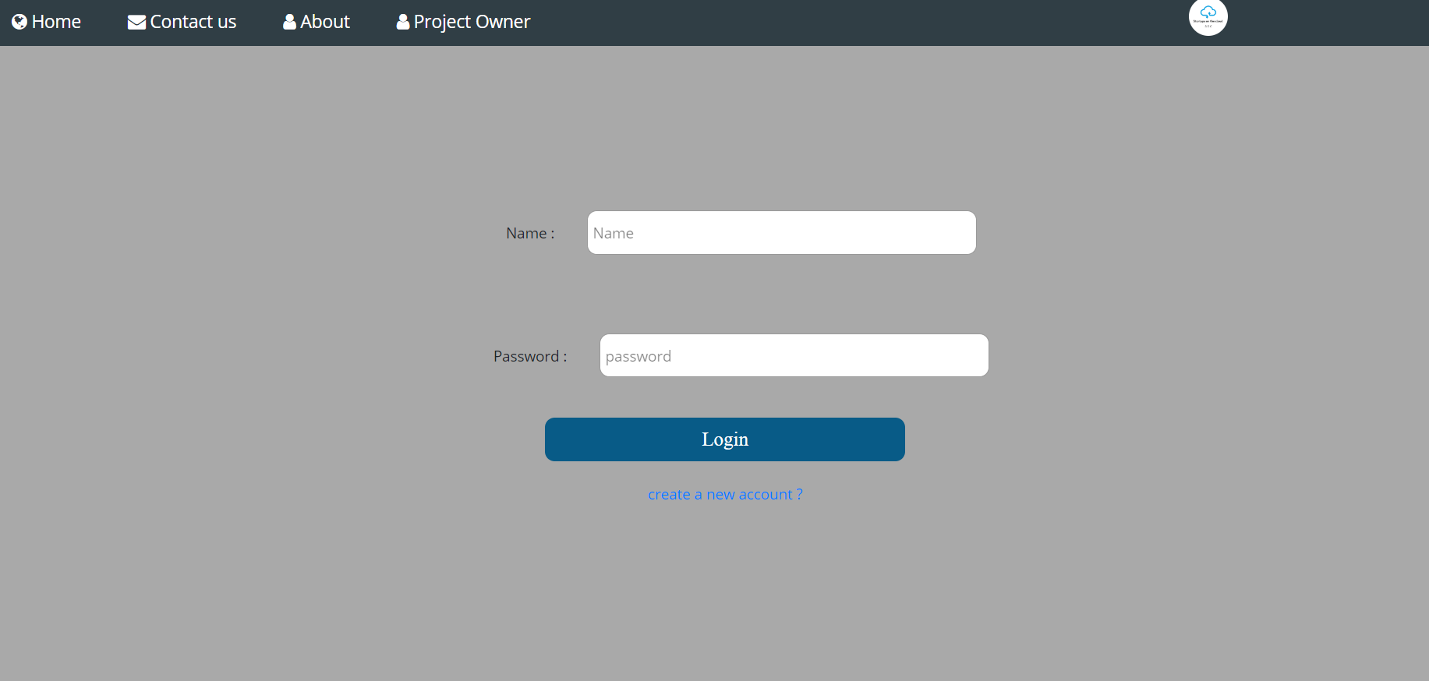

* Certain Category page

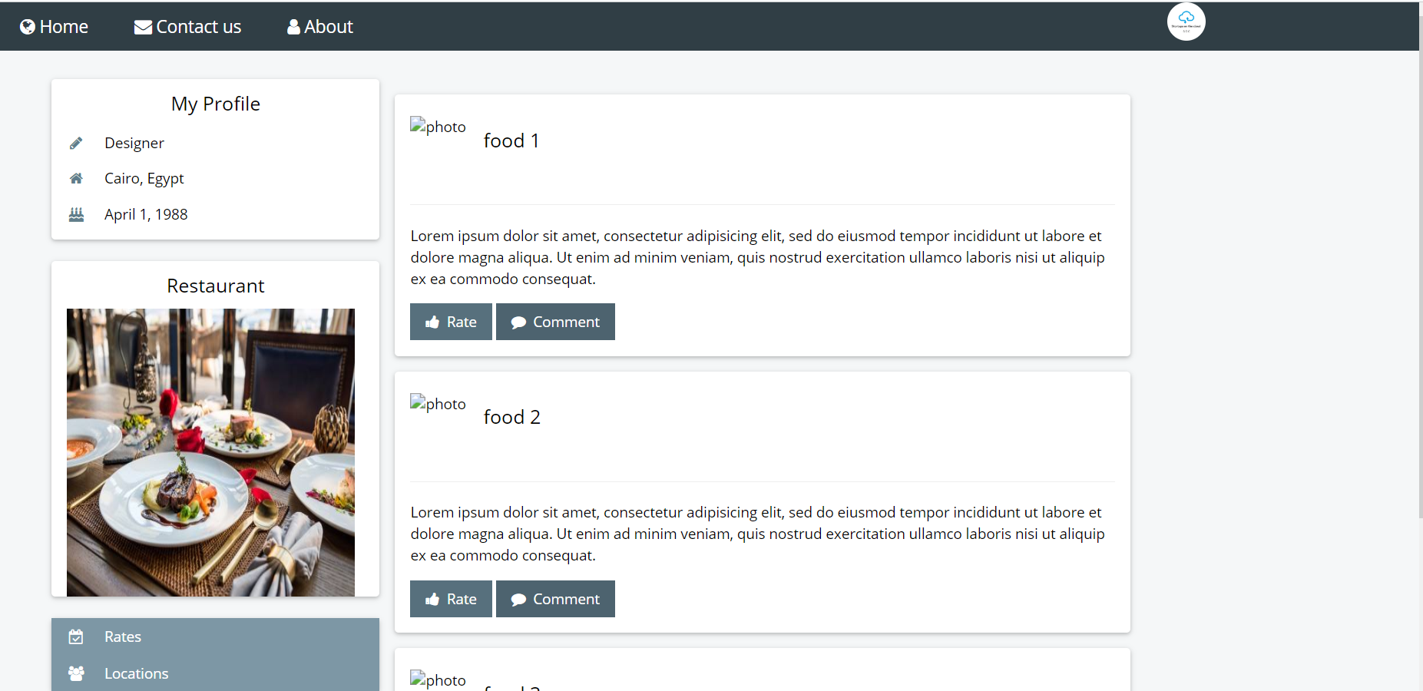

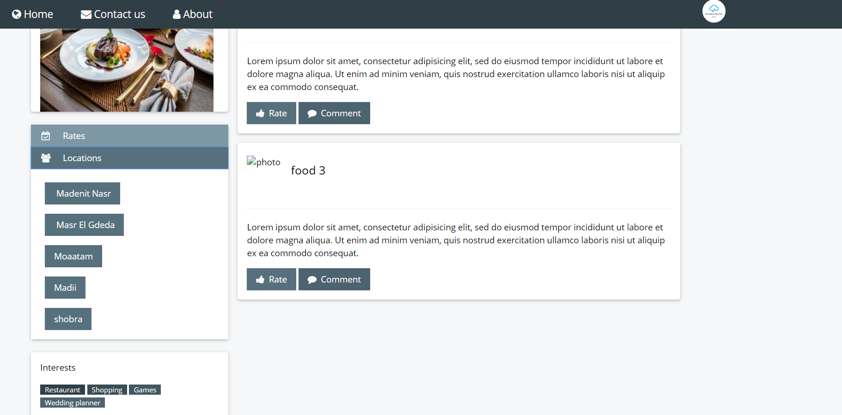

* Home page

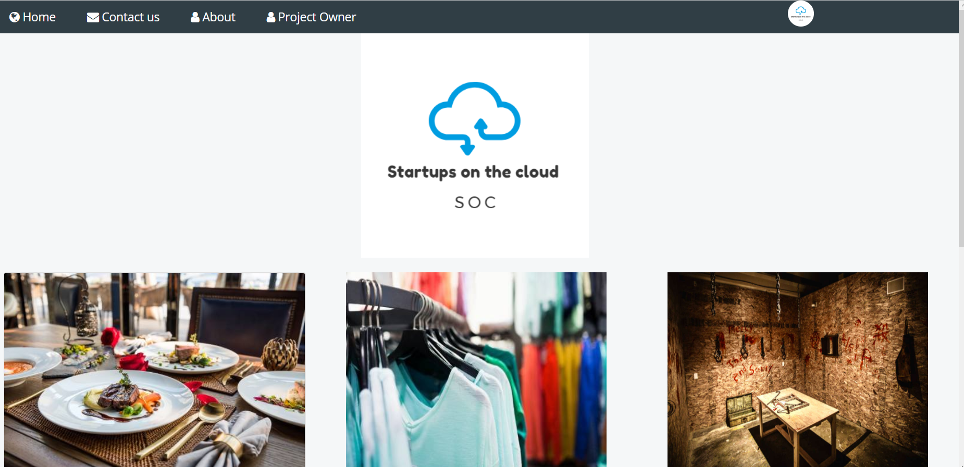

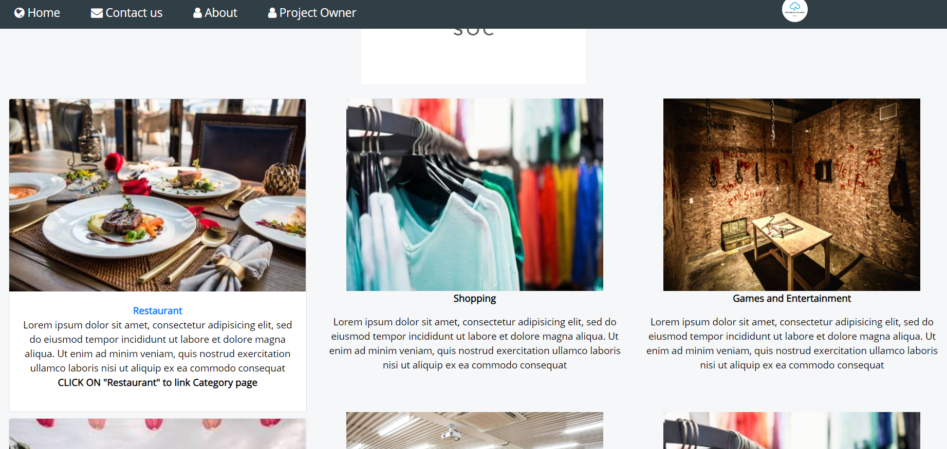

* Project Owner page

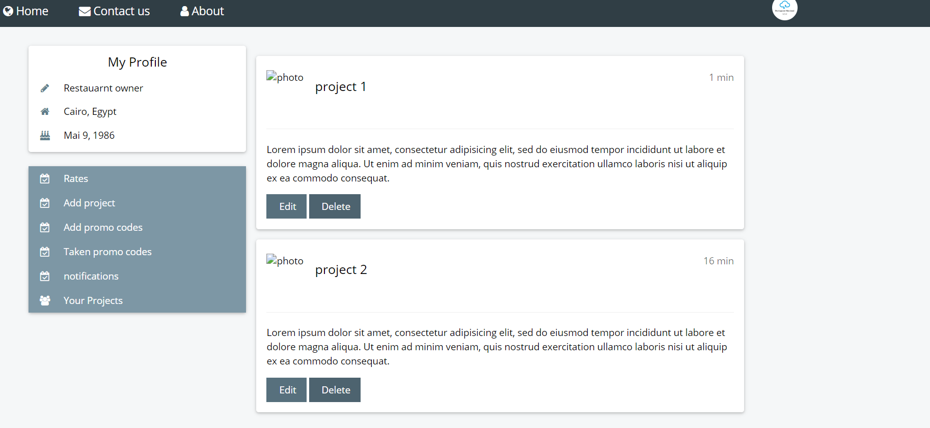

* Contact us

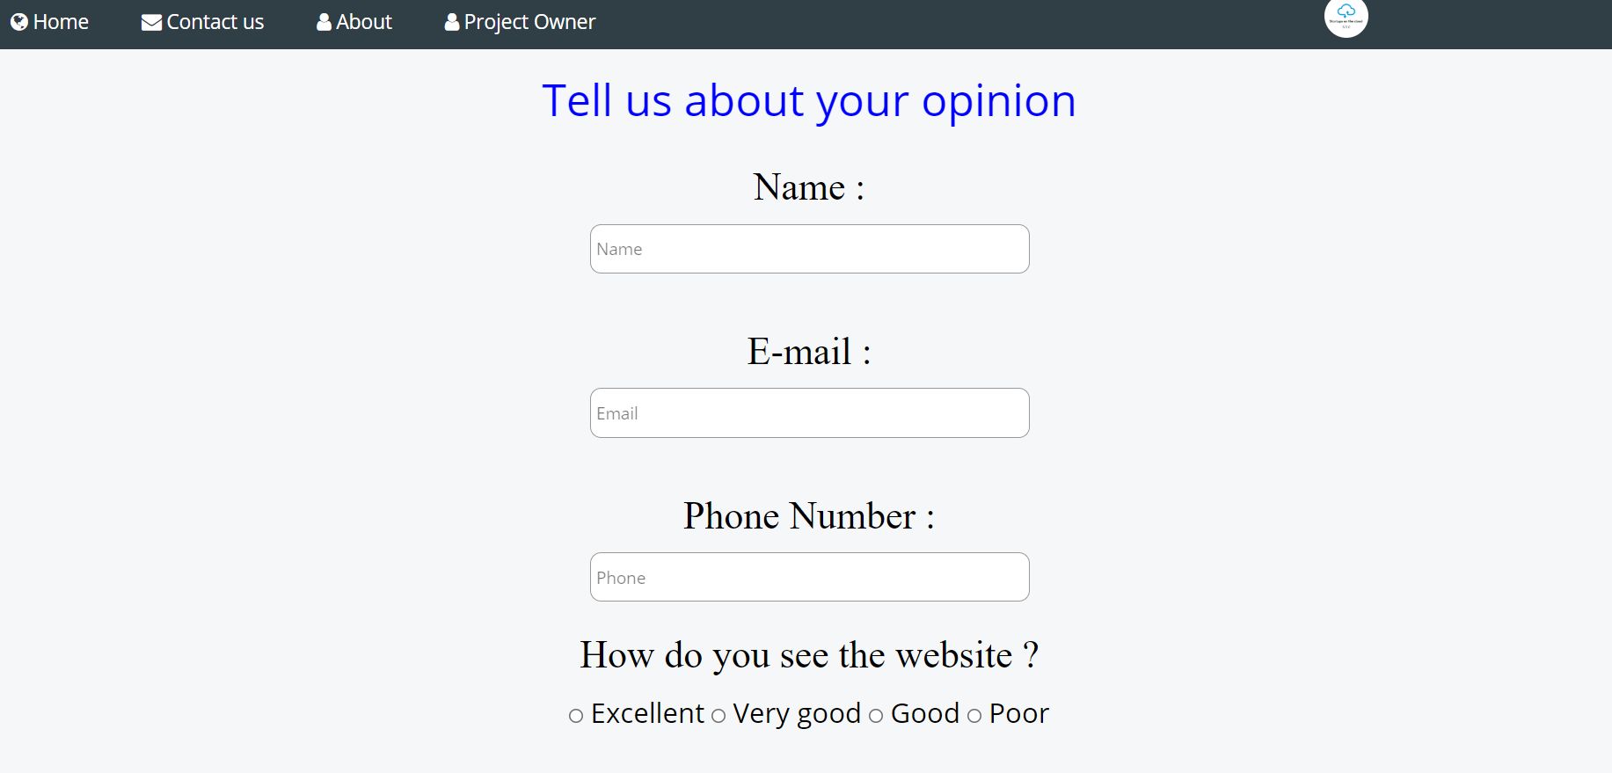

* About

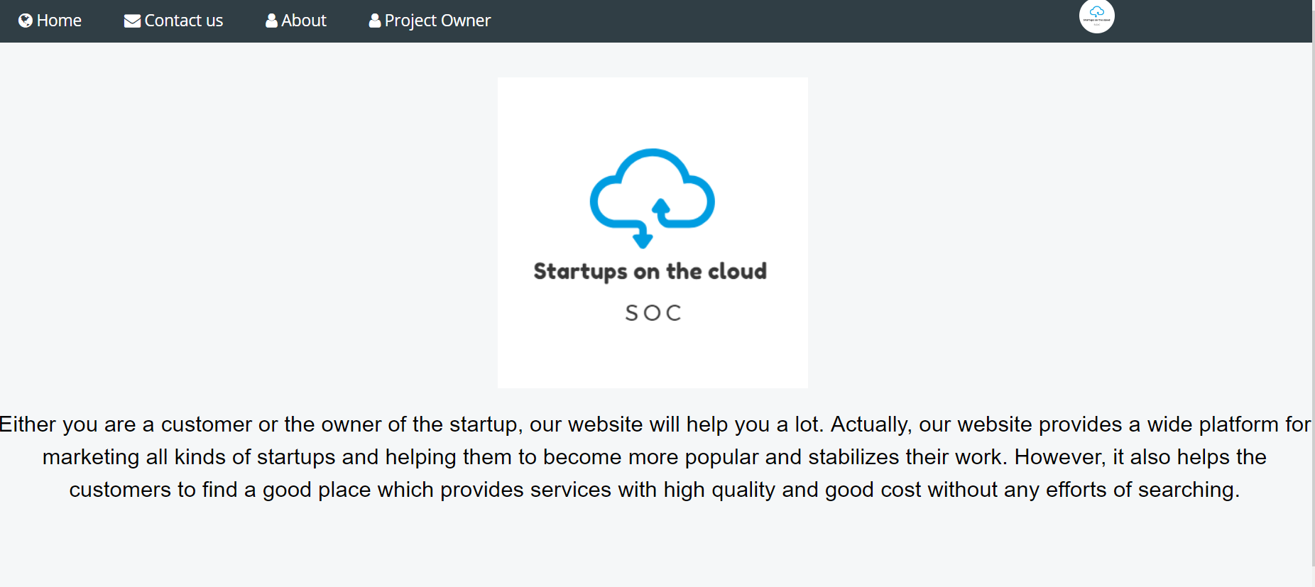

## 

## Hardware interfaces

**       **There is no hardware interfaces